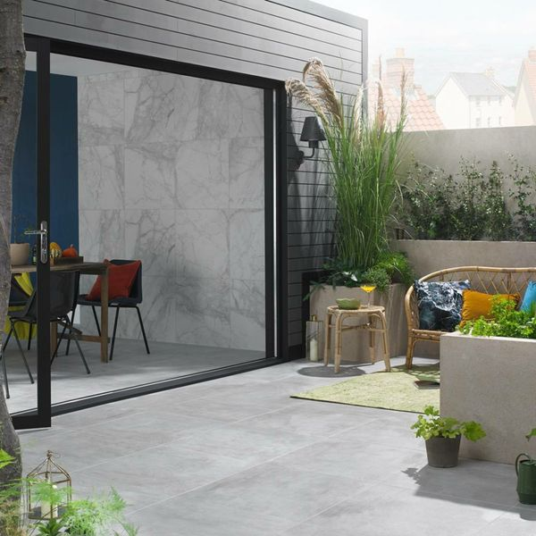**Mist Chalk Concrete Effect Porcelain Paving Slabs:**

## **Product Description**

Create a contemporary space in your garden with our Mist Chalk Concrete Effect Porcelain Paving Slabs. Perfect for emulating a natural look, these concrete effect slabs are designed in a pale white hue with a matt, textured surface. Perfectly suited to the Industrial trend, these stunning slabs can be paired with their interior counterpart for a seamless indoor/outdoor look!

**What’s special about these tiles?**

> Stylish concrete effect design

> 20mm thick durable porcelain

> Perfect for an industrial look

> Naturalistic matt, anti-slip finish

> Frostproof and long-lasting

## **Product INFO**

* Product ID: 801504
* Tiles Per SQM: 2.8437447568456
* Sale by: Per SQM
* Size: 593x593x20mm
* Weight: 15.50 KG
* Material Type: Porcelain
* Finish: Matt
* Colour: Grey
* Suitability: Floors, Walls
* Area Of Usage: External
* Grade: 4
* Rectified Edge: Yes
* Underfloor Heating: Yes
* Anti Slip Grade: R10 / 19-27 Degrees
* Document: [20mm Installation Guide](https://m2.wallsandfloors.co.uk/media/amasty/amfile/attach/20mm-installation-guide_4.pdf),[Cleaning and Protection Guide](https://m2.wallsandfloors.co.uk/media/amasty/amfile/attach/ltp_-_walls_floors_-_external_porcelain_-_cleaning_and_protection_guide_-_april_2020.pdf)
* Thickness (mm): 20